**Temporal and Spatial Shifts in Gun Violence, Before and After a Historic Police Killing in Minneapolis**

Ryan P. Larson1, N. Jeanie Santaularia2, and Christopher Uggen1

1 University of Minnesota - Twin Cities, Department of Sociology

2 University of North Carolina, Carolina Population Center

**Abstract**

In 2020, the United States experienced major social unrest in response to police killings, as well as a rise in the homicide rate but not the overall crime rate. This report uses Minnesota Hospital Association discharge data to evaluate the rate of firearm-related injuries occurring after the murder of George Floyd on May 25th, 2020. Interrupted time-series models indicate a significant increase in weekly firearm assault injuries post-murder, followed by a decrease, albeit not to pre-murder levels. Fixed-effects panel specifications corroborate this temporal pattern, while also documenting the spatial heterogeneity in the effect across Minneapolis, with more disadvantaged, historically Black communities experiencing the brunt of the increase in firearm assaults. These temporal effects remain after adjusting for changes in police activity and pandemic-related restrictions, indicating that the increase in violence was not a simple byproduct of post-killing changes in police behavior or COVID-19 response. These findings show how the deleterious consequences of police killings and social unrest are disproportionately borne by underserved communities.

**Background**

During the past year, the United States experienced major social unrest in response to several high-profile police killings of Black civilians. These high-profile killings catalyzed the growing social movement #Blacklivesmatter, which brings attention to the long history and contemporary realities of police violence and brutality, particularly against Black people (1, 2). These social tensions came to a head in Minneapolis, Minnesota after the highly publicized murder of George Floyd on May 25th, 2020 by police and the subsequent protest and social unrest. A widely reported spike in gun-related crime emerged after the murder, alongside claims that the rise in violence was due to changes in local police behavior (“depolicing”) in response to protest and social unrest (3, 4) and a broad national increase in homicide (5).

Research and public discourse in the aftermath of such violence has emphasized the temporal and spatial pattern of subsequent violent crime (6,7). Studies following the police killings of civilians have focused on the so-called ‘Ferguson effect’ following the death of Michael Brown in Ferguson, MO. Despite speculation that violent crime increased, particularly gun violence, there was no increase in homicides or other types of violent crime in St. Louis, Missouri (6,7). After the unrest following Freddie Gray’s arrest and killing in Baltimore, however, shootings and homicides increased in the following three months (8). To date, the studies investigating these trends and associations have largely analyzed data reported directly from police departments. These data are limited, however, due to (1) selectivity associated with systemic racial biases and the overrepresentation of communities of color in police and court data; and (2) potential misclassification of gun violence due to changes in policing, and subsequent detection and categorization of crime events, in a time of disruption. Moreover, the willingness to report to the police is likely diminished in the aftermath of police violence, especially in communities that are overpoliced and disproportionately impacted by gun violence (9). These points highlight the need for alternative data sources to track gun violence and crime independent of data collected by police. Although hospital data are not free of such biases, injury reports offer an independent and potentially more accurate source of information about violent injury.

In light of this background, the current analysis seeks to understand: (1) the temporal and spatial pattern of gun violence injuries in Minneapolis, pre- and post- the police killing of Mr. Floyd; (2) whether the patterns of gun violence injuries mirror prior work in Ferguson, Baltimore or elsewhere; and (3) to the extent that we observe a “Minneapolis effect,” whether disadvantaged communities experienced the greatest change.

**Results**

**Temporal Pattern of Firearm Assault Injuries** Figure 1 displays the weekly incidence of gun assault hospital discharges in Minneapolis from 2016-2020. We observe a sharp increase in the firearm assault injury rate from about .005 per 1,000 residents to .044 per 1,000 residents after the police killing of George Floyd, an eight-fold increase. After an initial spike, the rate fell to levels consistent with the pre-killing period.

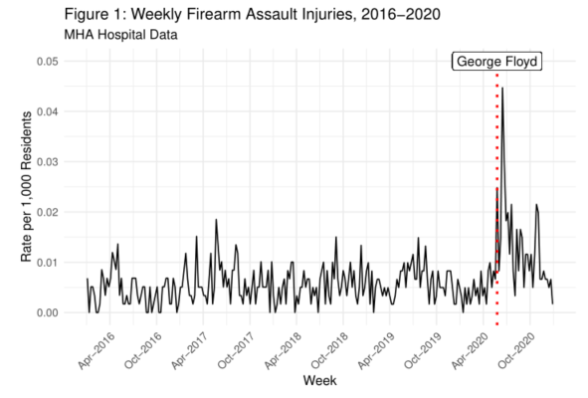

**Interrupted Time Series Models** Table 1 presents interrupted time series models of the firearm assault injury rate in Minneapolis from 2016-2020. Each model includes a time indicator for each period[1] of analysis, as well as controls for seasonality and police behavior. Model 2 is estimated on disaggregated weekly Zip Code Tabulation Area data, and includes ZCTA fixed effects to account for time-constant unobserved heterogeneity. Controlling for seasonal expectations, Model 1 indicates that the rate of firearm assault injuries rose in the three months post-killing, with an increase of .014 firearm assaults injuries per 1,000 residents over those three months on average. In the remaining weeks after the twelve week post-killing period, the rate declined .004 in this period, indicating that the rate did not return to pre-killing levels after the initial spike. In Model 2 these results are corroborated with within-ZCTA comparisons, with the post-killing period marked by a .97 increase in firearm assault injuries incidents per 1,000 residents, followed by a decline (-.35) in the period three months post-killing. Upon controlling for changes in police behavior in both models, the event time indicators remain largely unaltered in direction or magnitude, suggesting that changes in local policing did little to drive the increase in gun violence. If changes in police behavior were a key driver of this post-killing increase, then the inclusion of police measures should have attenuated the post-killing effect, which we do not observe. This analysis provides evidence of a “Minneapolis effect,” as the firearm assault injury rate increased above and beyond seasonal expectations, but not one driven by changes in police behavior or COVID-19 related state policy changes.

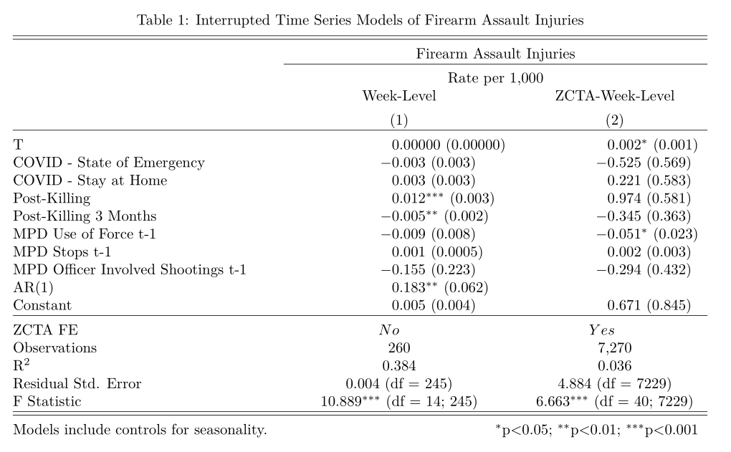

**Spatial Heterogeneity in Post-Killing Effects** Figure 2 displays firearm injury rates by ZCTA and period. A similar temporal pattern emerges, but this pattern is highly localized. The model includes interaction terms between the ZCTA-fixed effects and the time indicators, which allows the time effects to vary by ZCTA.[2] Specifically, ZCTAs 55411, 55412, 55404, and 55415 - historically Black ZCTAs and marked by disadvantage - experienced significantly higher increases than other ZCTAs.[3] In addition, the ZCTAs with significantly higher post-killing effects tended to also be those with the highest incidence of firearm assault injury in the pre-killing period, as indicated by the ZCTA main effects. These spatiotemporal patterns indicate that communities that experienced the largest increases in firearm assault injury incidence after the murder of Mr. Floyd were those *already experiencing* both higher levels of social disadvantage and firearm injury incidence.

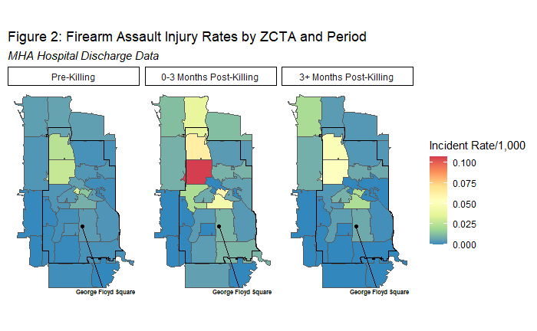

**Discussion**

We find that firearm assault injury rates increased after the murder of George Floyd by police, after statistically adjusting for seasonality, changes in police behavior, and COVID-19-related state policy changes. Further, our models indicate that changes in police behavior did not drive the temporal changes in gun assault injuries. These findings reveal a “Minneapolis effect,” wherein an extreme and high-profile police killing significantly altered the temporal pattern of firearm assault injuries. This is consistent with past research demonstrating similar effects, such as in Baltimore (8). Our study adds important information to this literature by using a measure of gun violence that is less prone to selection concerns. In addition, our analysis shows that communities already experiencing higher levels of social disadvantage and firearm incidence had disproportionate increases in firearm assault injury after the murder of Mr. Floyd. Further research is needed to elucidate these processes and their longer-term impact, but the pattern of findings is consistent with the idea that police violence impacts vulnerable communities by destabilizing social order and threatening public safety.

**Methods and Materials**

All results are based on the Minnesota Hospital Association discharge data merged to data from the Minnesota Department of Natural Resources, the Minneapolis Police Department, and the American Community Survey. We analyze the data using interrupted time series models at the week-level and fixed-effects panel models at the ZCTA-week level. The ZCTAs making up our population a) intersected at least partially within the border of Minneapolis, or b) were neighbors by queen contiguity, which defines neighbors as sharing a common border or vertex.

**References**

# Nummi, J., Jennings, C., & Feagin, J. 2019. “# BlackLivesMatter: Innovative Black Resistance.” *Sociological Forum* 34: 1042-1064.

1. Edwards, F., Lee, H., & Esposito, M. 2019. “Risk of Being Killed by Police Use of Force in the United States by Age, Race–Ethnicity, and sex.” *Proceedings of the National Academy of Sciences*, 116 (34), 16793-16798.
2. Jany, Libor and Liz Sawyer. 2020. “Gun Violence Soars amid Crises of Health, Public Trust, Officer Reluctance.” *Star Tribune*, June 20 https://www.startribune.com/surge-in-gun-violence-tests-minneapolis-leaders/571524202/.
3. Shjarback, J. A., Pyrooz, D. C., Wolfe, S. E., & Decker, S. H. 2017. “De-Policing and Crime in the Wake of Ferguson: Racialized Changes in the Quantity and Quality of Policing among Missouri Police Departments.” *Journal of Criminal Justice*, *50*: 42-52.
4. Federal Bureau of Investigation. 2021. “FBI Releases 2020 Crime Statistics”. Retrieved 9/29/2021 ( <https://www.fbi.gov/news/pressrel/press-releases/fbi-releases-2020-crime-statistics>).
5. Rosenfeld, R. 2015. “Ferguson and Police Use of Deadly Force.” *Missouri Law Review*, *80*, 1077.
6. Pyrooz, D. C., Decker, S. H., Wolfe, S. E., & Shjarback, J. A. 2016. “Was There a Ferguson Effect on Crime Rates in Large US Cities?.” *Journal of Criminal Justice*, *46*, 1-8.
7. Morgan, S. L., & Pally, J. 2016. “Ferguson, Gray, and Davis: An Analysis of Recorded Crime Incidents and Arrests in Baltimore City, March 2010 through December 2015.” Retrieved 9/29/2021 (<https://osf.io/preprints/socarxiv/nshme/>).
8. Desmond, M., Papachristos, A. V., & Kirk, D. S. 2016. “Police Violence and Citizen Crime Reporting in the Black Community. *American Sociological Review*, 81(5): 857-876.

**Methods Appendix**

Minnesota Hospital Discharge data was used to create our dependent variable, firearm assault injuries. Inpatient and outpatient data from 2016-2020 utilizing International Classification of Diseases (ICD)-10 codes X93-X95 were used to define firearm assault injuries.

To measure the effects of the events of interest, we create time indicators that measure the average rate in the period as compared to the pre-killing baseline, following previous empirical work on crime rates in Baltimore (5,6). We create event indicators at four key points, two of which are related to the COVID-19 pandemic: 3/13/2020 at the inception of Governor Walz’s State of Emergency order, and from 3/28-2020-5/28/2020 at the introduction and conclusion of Governor Walz’s Stay at Home order. These time indicators adjust for changes in firearm assault incidence related to significant policy events in the course of the COVID-19 pandemic and related patterns of social interaction. The key time indicators of interest are the police killing of George Floyd on 5/25/2020 (post-killing), and three months after this event, dated 8/25/2020 (three months post-killing). These are the focal time indicators of interest in the analysis, and represent changes in firearm assault incidence in those time periods as compared to periods in the pre-killing period.

We also merge measures of both seasonality and police behavior onto the weekly hospital data. Following previous scholarship (5,6) we include the weekly maximum temperature (degrees Fahrenheit), snowfall (in.), and precipitation (in.) from the Minnesota Department of Natural Resources as measured at the Minneapolis/St. Paul Threaded Record station (<https://www.dnr.state.mn.us/climate/historical/daily-data.html?sid=mspthr&sname=Minneapolis/St%20Paul%20Threaded%20Record&sdate=2010-01-01&edate=por>). A measure of the average weekly number of hours of dark before 12pm is also included as further adjustment for seasonality[4]. Finally, we construct the proportion of days in the week K-12 Minneapolis Public Schools were in session based on school calendars from 2016-2020 (https://mpls.k12.mn.us/calendars).

We also merge in measures of police behavior from the Minneapolis Police Department as reported on <https://opendata.minneapolismn.gov/>. Specifically, we aggregate use of force incidents, police stops, and officer involved shootings to both the week and ZCTA-week level from 2016-2020, placing each incident in each ZCTA-week by the date of incident and the longitude and latitude coordinates of the location of the event.

Our analytical strategy is two-fold: we first estimate interrupted time-series models on week-level data[5], then estimate fixed-effects panel models on Zip Code Tabulation Area (ZCTA)-week level data to corroborate the aggregate findings with *within-ZCTA comparisons,* which net out time-constant unobserved heterogeneity. Finally, we estimate ZCTA-specific post-killing effects[6] to examine the spatial heterogeneity in the post-killing effect across communities.

1. We construct linear time indicators at four key events in 2020: 1) the introduction of the Governor’s COVID-19 State of Emergency order (03/13/2020), 2) the introduction and conclusion of the Governor’s COVID-19 Stay at Home order (03/28/2020-05/28/2020), 3) the police killing of George Floyd (05/25/2020), and 4) three months following the police killing of George Floyd (08/25/2020).
2. Full model available upon request to the corresponding author.
3. A random effects specification with cross-level interactions indicates that the post-killing effect was significantly higher in ZCTAs with higher proportions of Black residents. Model is available upon request from the corresponding author.
4. This measure is calculated via the ‘suncalc’ package in R, which, conditional on the week and location, calculates the sunset on each particular day. We then calculate the time difference between sunset and midnight. We aggregate this to the average amount per day in each to represent our weekly measure of darkness before 12 midnight.
5. Significant autocorrelation was detected at a lag of 1 in partial autocorrelation functions of the residuals, and therefore an AR(1) component was added to the model to account for this serial dependence.
6. These are calculated by estimating interaction effects between the time indicators and ZCTA fixed effects, and combining the main effects and interaction effects within each ZCTA.